**Lab-5**

**Q1. Searching an element in an array.**

**Source code:**

**import java.util.Scanner;**

**class Searching**

**{**

**public void searchVal(int arr[], int n)**

**{**

**Scanner sc = new Scanner(System.in);**

**int val, pos = -1; // Enter value to search**

**val = sc.nextInt();**

**int mid, f=0, l = n-1;**

**for (int i=0; i<n; i++)**

**{**

**mid = f + (l-f)/2;**

**if(arr[mid] == val)**

**{**

**pos = mid;**

**}**

**else if(arr[mid] > val)**

**{**

**l = mid-1;**

**}**

**else{**

**f = mid + 1;**

**}**

**}**

**if(pos == -1)**

**System.out.println("Number not present in the array ");**

**else**

**System.out.println("Number found at : " + pos);**

**}**

**}**

**class Main**

**{**

**public static void main(String[] args)**

**{**

**Scanner sc = new Scanner(System.in);**

**int n, pos;**

**n = sc.nextInt();**

**int arr[] = new int[n];**

**for(int i=0; i<n; i++)**

**{**

**arr[i] = sc.nextInt();**

**}**

**Searching obj = new Searching();**

**obj.searchVal(arr, n);**

**}**

**}**

**Output:**

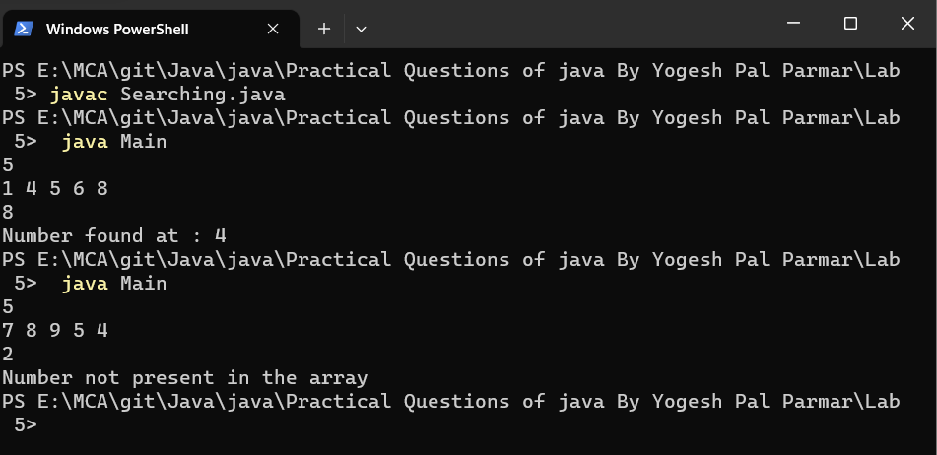

**Q2. Deleting in element from an array.**

**Source code:**

**import java.util.Scanner;**

**class Deleting**

**{**

**public int searchVal(int arr[], int n)**

**{**

**Scanner sc = new Scanner(System.in);**

**int val, pos = -1; // Enter value to Delete**

**val = sc.nextInt();**

**int mid, f=0, l = n-1;**

**for (int i=0; i<n; i++)**

**{**

**mid = f + (l-f)/2;**

**if(arr[mid] == val)**

**{**

**pos = mid;**

**}**

**else if(arr[mid] > val)**

**{**

**l = mid-1;**

**}**

**else{**

**f = mid + 1;**

**}**

**}**

**return pos;**

**}**

**public int deleteVal(int arr[], int n, int pos)**

**{**

**if(pos == -1)**

**{**

**System.out.println("Number not present in the array ");**

**return 0;**

**}**

**int arr2[] = new int[n-1];**

**for(int i=0, k=0; i<n; i++)**

**{**

**if(i == pos)**

**{**

**continue;**

**}**

**arr2[k++] = arr[i];**

**}**

**for(int i=0; i<n-1; i++)**

**{**

**System.out.print(" " + arr2[i]);**

**}**

**return 0;**

**}**

**}**

**class Test**

**{**

**public static void main(String[] args)**

**{**

**Scanner sc = new Scanner(System.in);**

**int n;**

**n = sc.nextInt();**

**int arr[] = new int[n];**

**for(int i=0; i<n; i++)**

**{**

**arr[i] = sc.nextInt();**

**}**

**Deleting obj = new Deleting();**

**int pos = obj.searchVal(arr, n);**

**//System.out.println(pos);**

**obj.deleteVal(arr, n, pos);**

**}**

**}**

**Output:**

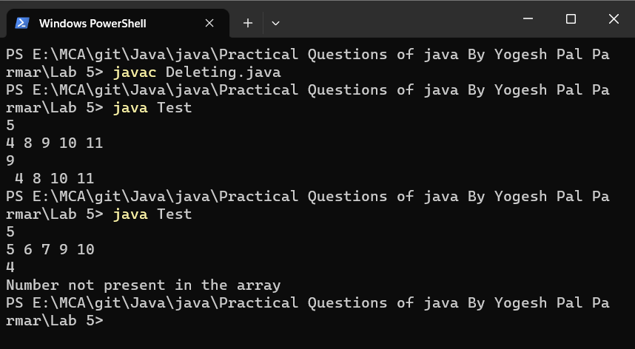

**Q3. Jagged array (Sum of all even rows).**

**Source code:**

**import java.util.Scanner;**

**class Jagged**

**{**

**public int evenSum(int arr[][], int n)**

**{**

**int sum = 0;**

**for(int i=0; i<n; i++)**

**{**

**if(i%2 == 0)**

**{**

**for(int j=0; j<arr[i].length; j++)**

**{**

**sum = sum + arr[i][j];**

**}**

**}**

**}**

**System.out.println("Required sum : " + sum);**

**return 0;**

**}**

**}**

**class Temp**

**{**

**public static void main(String[] args)**

**{**

**Scanner sc = new Scanner(System.in);**

**int n;**

**System.out.println("Enter number of rows ");**

**n = sc.nextInt();**

**int arr[][] = new int[n][];**

**System.out.println("Enter number of columns in each row");**

**for(int i=0; i<n; i++)**

**{**

**int col = sc.nextInt();**

**arr[i] = new int[col];**

**}**

**System.out.println("Enter elements in the array ");**

**for(int i=0; i<n; i++)**

**{**

**for(int j=0; j<arr[i].length; j++)**

**{**

**arr[i][j] = sc.nextInt();**

**}**

**}**

**System.out.println();**

**for(int i=0; i<n; i++)**

**{**

**for(int j=0; j<arr[i].length; j++)**

**{**

**System.out.print(" " + arr[i][j]);**

**}**

**System.out.println();**

**}**

**Jagged obj = new Jagged();**

**obj.evenSum(arr, n);**

**}**

**}**

**Output:**

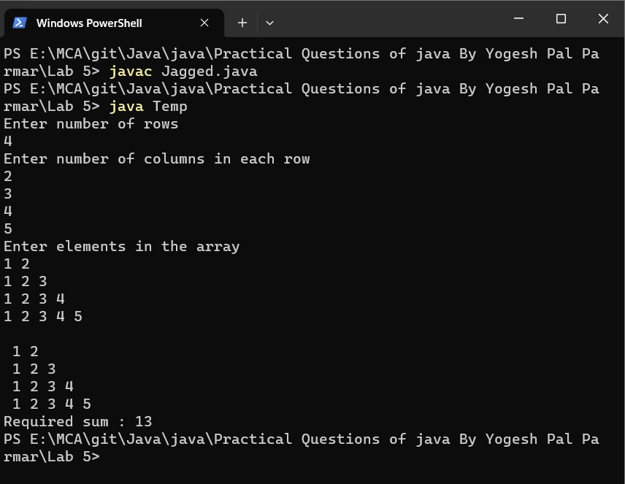

**Q4. Create a class Author with the following information:**

**Merber variables:**

**Name (String), email (String) and gender (char) Parameterized Constructor: To Initialize the variables.**

**Create a class Book with the following Information**

**Member variables:**

**Name (String), author (of the class Author you have just created), price (double) and eqtyInstock (In Parameterized Constructor: To initialize the variables Getters and Setters method for all the member variables. In the main method create a book object and print all details of the book.**

**Source code:**

**class Author**

**{**

**public String name;**

**public String email;**

**public char gender;**

**Author()**

**{**

**this.name = name;**

**this.email = email;**

**this.gender = gender;**

**}**

**void setName(String name)**

**{**

**this.name = name;**

**}**

**String getName()**

**{**

**return name;**

**}**

**void setEmail(String email)**

**{**

**this.email = email;**

**}**

**String getEmail()**

**{**

**return email;**

**}**

**void setGender(char gender)**

**{**

**this.gender = gender;**

**}**

**char getGender()**

**{**

**return gender;**

**}**

**}**

**class Book extends Author**

**{**

**Book()**

**{**

**super();**

**}**

**public String nameOfBook;**

**public double price;**

**public double eqityInStock;**

**Book(String nameOfBook, double price, double eqityInStock)**

**{**

**this.nameOfBook = nameOfBook;**

**this.price = price;**

**this.eqityInStock = eqityInStock;**

**}**

**void setNameOfBook(String nameOfBook)**

**{**

**this.nameOfBook = nameOfBook;**

**}**

**String getNameOfBook()**

**{**

**return nameOfBook;**

**}**

**void setPrice(double price)**

**{**

**this.price = price;**

**}**

**double getPrice()**

**{**

**return price;**

**}**

**void setEqityInStock(double eqityInStock)**

**{**

**this.eqityInStock = eqityInStock;**

**}**

**double getEqityInStock()**

**{**

**return eqityInStock;**

**}**

**}**

**class Test**

**{**

**public static void main(String[] args)**

**{**

**Author ob1 = new Author();**

**Book ob2 = new Book("NCERT", 250.0, 10);**

**ob2.setNameOfBook("NCERT");**

**System.out.println(ob2.getNameOfBook());**

**ob2.setPrice(250.0);**

**System.out.println(ob2.getPrice());**

**ob2.setEqityInStock(10);**

**System.out.println(ob2.getEqityInStock());**

**ob1.setName("Yogesh");**

**System.out.println(ob1.getName());**

**ob1.setEmail("parmaryogeshpal@gmail.com");**

**System.out.println(ob1.getEmail());**

**ob1.setGender('M');**

**System.out.println(ob1.getGender());**

**}**

**}**

**Output:**

